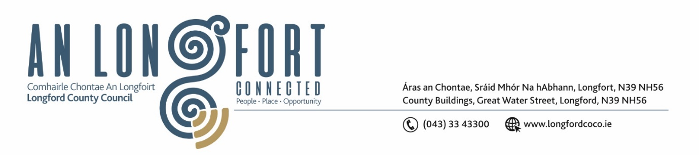

***Please note meeting will be held in the Council Chamber and via Microsoft Teams.***

6 Nollaig 2023

**Chuig: Gach Ball don Chomhairle**

A Chomhairleoir,

Iarrtar ort bheith i láthair ag Cruinniú Míosuil Chomhairle Chontae Longfoirt a tionólfar i Seomra na Comhairle, Aras an Chontae, Longford agus via MS Teams are an **Chéadaoin 13ú Nollaig 2023 ag 4pm** chun gnó a dhéanamh d’réir an Chláir thíos.

You are requested to attend the Monthly Meeting of Longford County Council to be held in the **Council Chamber and via Microsoft Teams** on **Wednesday 13 December 2023 at 4pm** to transact business, as set out on the Agenda hereunder.

Mise le meas,

**__________________**

***Claire McNabola***

***Meetings Administrator.***

**C L Á R**

Prayer before meeting.

1. Confirmation of Minutes:
2. Monthly meeting of Longford County Council held on 8 November 2023 – enclosed
3. Finance Committee meeting of Longford County Council held on 27 November 2023 – enclosed
4. Matters Arising.

**3.** Declaration of Interest by Members.

1. To note Management Report – to follow.

**5.** To note adopted Minutes of Corporate Policy Group Meeting held on the

10 October 2023 – enclosed.

**6. Housing, Planning, Regeneration & Capital Projects**

1. Noting of Signage Policy – Erection of Advertising and Directional Signage – enclosed.
2. Part VIII No 113 Construction of Industrial / Commercial building at Knock, Lanesboro.

**7. Community, Library and Cultural Services, Corporate and Human Resources**

1. Noting of Adopted Minutes of the Placemaking Strategic Policy Committee held on the 4 December 2023 - enclosed
2. CE Report on Implementation of the Corporate Plan
3. Electoral Commission – Overview and Draft Research Programme 2023-2026 – enclosed
4. Consideration of Local Economic and Community Plan – To Follow
5. Community Grant Support Scheme 2024
6. Overview of ‘See something say something’
7. Notice of Motions, submitted by Councillors, as listed hereunder

**Councillor Peggy Nolan**

That this council set in motion plans to provide a family resource centre in our county town. This request is vital for our community.

**8. Infrastructure, Climate Action and Innovation**

1. Notice of Motions, submitted by Councillors, as listed hereunder

**Councillor Mark Casey**

That this council completes a survey on roadside trees which are rotting due to Ash Dieback and contact the landowners to ensure that they are removed. There was no fatalities due to Storm Debi, but we must take action now to ensure safety for all road users in the future

**9. Enterprise and Ukrainian Humanitarian Response**

1. Consideration of Draft Tourism Strategy - enclosed
2. Proposed amendment to the Occupation of Vacant Commercial Premises Incentive Scheme – enclosed
3. Notice of Motions, submitted by Councillors, as listed hereunder

**Councillor Uruemu Adejinmi**

I call on Longford County Council to introduce a Retail Incentive Scheme to address the issue of vacant retail units throughout the County. The scheme if introduced for 2024 would incentivise occupancy of vacant retail units in our towns and villages and would help address urban dereliction and the high percentage of commercial vacancy that exists at present. It would support our urban regeneration and town centre efforts, helping to revitalise and re-energise our Town Centres, encouraging more visitors and improving footfall in our towns.

**10. Finance and Information Technology**

1. Request for nomination for external director to sit on the Yard Hub CLG Board of Directors.
2. Notice of Motions, submitted by Councillors, as listed hereunder

**Councillor Seamus Butler**

That the report on the Conditions of Sale of the former LEDCO building on the Ballinalee Road be furnished to the Members and in particular the condition requiring the creation of 40+ higher end R&D positions within 5 years.

**11. General**

1. Notice of Motions, submitted by Councillors, as listed hereunder

**Councillor XX**

….

**12. Date of January Meeting**

**13. Correspondence**

1. Correspondence received from the Department of Rural and Community Development re. CLÁR project requirements – enclosed.

**14. Votes of Sympathy**